POSTER TRACK EXTENDED ABSTRACT PREPARATION GUIDE AND SUBMISSION

INSTRUCTIONS
John Modeller¹, Jane Simulator², and Another Author²
¹Technical University, Cambridge, MA
²Another Institution, Some City, Some Country
The names and affiliations MUST NOT be included in the draft submitted for review.
The header consists of 10 lines with exactly 14 point spacing.
The last line below should be left blank.

Abstract
This document explains how to prepare an extended abstract for poster submission to the 2026 European Conference on Computing in Construction. It also includes the instructions for sub-mission and some other information. This document can be used as a template with MS-Word.

Introduction
The extended abstract should be prepared in A4 size with 25 mm margins at top and bottom, and 20 mm margins at left and right. Use font type Times (Times New Roman) for the entire document with different style at different part of the extended abstract, as explained later in each section.
The top section of the first page of the extended abstract is used for the title of the extended abstract, list of authors, and authors affiliation. This section consists of 10 lines of exactly 14 points spacing.
After these 10 lines, the rest of the document is in two- column format, with a space between the two columns of 8 mm. The space between the columns should be centred on the extended abstract.
Please DO NOT include page numbers. The main text of
extended abstract submissions should not be longer than
800 words and the total no of pages should be less than 2 pages.

Parts of the extended abstract

Title, authors, and authors’ affiliations
Titles should be in bold font size 12 points. Do not use more than 2 lines for the title and try to limit it to ten words.
Authors, authors affiliations, and other information should be in font size 12. More than one affiliation of an author should be indicated by numbers, superscripted after the authors name. Do not number the authors if they are all from the same institution.
You can add contact information (e-mails, telephone numbers, postal address, etc) and other information as you wish. However, the 10 lines limitation applies. If you need less than 10 lines for all the information, please leave the other lines blank.

Abstract
The abstract of your poster should be no longer than 100 words. Abstracts must clearly identify (i) what is the current state of the art, (ii) what are its deficiencies, (iii) what methods have been applied, (iv) what are the results, and (v) what is the lasting contribution of the submission

Main body
The main body of the extended abstract should contain (but is not limited to):
- Introduction
- Simulation and/or experiment
- Discussion and result analysis
- Conclusions
- Add other sections as you wish
The headings of each section should use 12-point font, with 6 and 3 points spacing above and below. The headings of the subsections should NOT be numbered, use 10-point font (in bold), with 6 and 3 points spacing above and below. The text should be typed in 10-point font with spacing of 12-points. Neither the sections or subsections should be numbered. Add the following sections if applicable:
- Acknowledgements
- Nomenclature

Figures and Tables
Figures and Tables are preferably included in the text where they are discussed rather than at the end of the extended abstract. Both must have a number and caption. Figure captions should use 9-point font. Figure 1 is an example of an image graph in the text with a caption below the figure. Please include a 3-pt blank line above the figure and below the caption (formatting style “Small Space”). Make sure text elements in figures are easily readable, high-resolution images are preferable. Colour images are welcome.

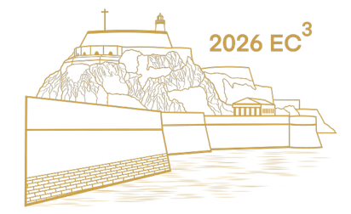
Figure 1: Example figure layout

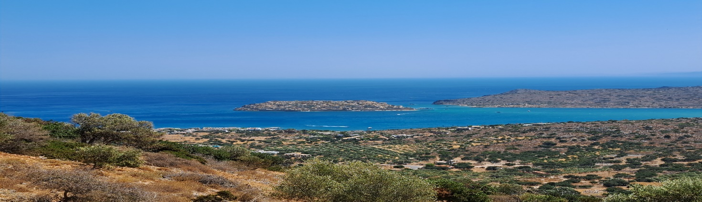
Oversized figures and tables may be included across both columns of the text (e.g. Figure 2). However, you should arrange the layout properly so that such images appear at the top or the bottom of the page, or on a separate page.
Figure 2: Example of a double-width image

Table 1 shows an example of a table. The caption should be on the top of the table. Please include a 3-pt blank line above the figure and below the caption (formatting style “Small Space”). Tables should include borders at the top and bottom of the header row. Tables should include a border under the bottom row of the table. Tables should not include vertical borders (i.e. left and right borders).

Table 1: Example of a table where the caption should be on top of the table
Heading 1 | Heading 2 | Heading 3
Entry 1A | Entry 2A | Entry 3A
Entry 1B | Entry 2B | Entry 3B

References
All publications cited in the text should be listed at the end of the extended abstract and should be ordered alphabetically by author name. All lines, other than the first in each entry, should be indented. In the main text, use the Harvard referencing style (e.g. (Lilis et al., 2017) or (O’Donnell et al., 2013)).

Equations
Each significant equation or formula should be displayed on a separate line. Centre equations and place consecutive equation numbers flush right in parentheses. For example,
$a^{2}+b^{2}=c^{2}$ (1)
Mathematical symbols should be clear to avoid ambiguities. Equations should be referenced by their number as in (1). Symbols used in equations and in the main text should be italicised. A brief description of the symbols used in your extended abstract should be added in a nomenclature section at the end of the text or inline with the text where the symbols are first used.

If you use MS-Word
This document can be used as a template for use with MS-Word. Please use the style for each section, as it has been defined in this template. You can use this document directly, cut-and-paste your extended abstract from other document(s) into this document, or import this style into another document (open the style organizer (Format – Style and click “organizer”) and replacing all styles with those from this document). Submission of the extended abstract must be in PDF format.

Submission instructions
- To enable the blind review process please do not include your name and affiliation on the draft submitted for review. This should be added at time of camera ready submissions.
- Please convert your entire document to PDF format. Other formats are NOT acceptable.
- Extended abstracts must be 2 pages long or a maximum of 800 words, whichever is less.
- You can use any file name, but please do not use special characters, umlaut, etc.
- The maximum file size is 10MB, but please use vector graphics where possible to reduce your file size.
- If your extended abstract has not met the requirements for submission, your file will not be processed for review and you will be requested to resubmit. If everything is in order, the extended abstract will be up-loaded to the review area of the conference web site.

Conclusions
This paper has described how to prepare an extended abstract for submission to the 2026 European Conference on Computing in Construction. Good luck with your extended abstract.

Acknowledgments
This document was derived from the author guidelines used for the 2003, 2005, 2008, 2014, and 2017 Building Simulation Conferences and the 2019, 2022, 2023 EC3 Conferences.

References
The first reference line should be left justified. All following reference lines should be indented 0.35 cm (formatting style “Bibliography”). A 6-point space should follow each reference.
Lilis, G.N., Giannakis, G.I. & Rovas, D.V. (2017) Automatic generation of second-level space boundary topology from IFC geometry inputs. Automation in Construction, 76, p.pp.108–124.
O’Donnell, J., Maile, T., Settlemyre, K. & Haves, P. (2013) A visualization environment for analysis of measured and simulated building performance data. In: IBPSA Building Simulation 2013. Chambéry, France. Chambéry, France, IBPSA.

